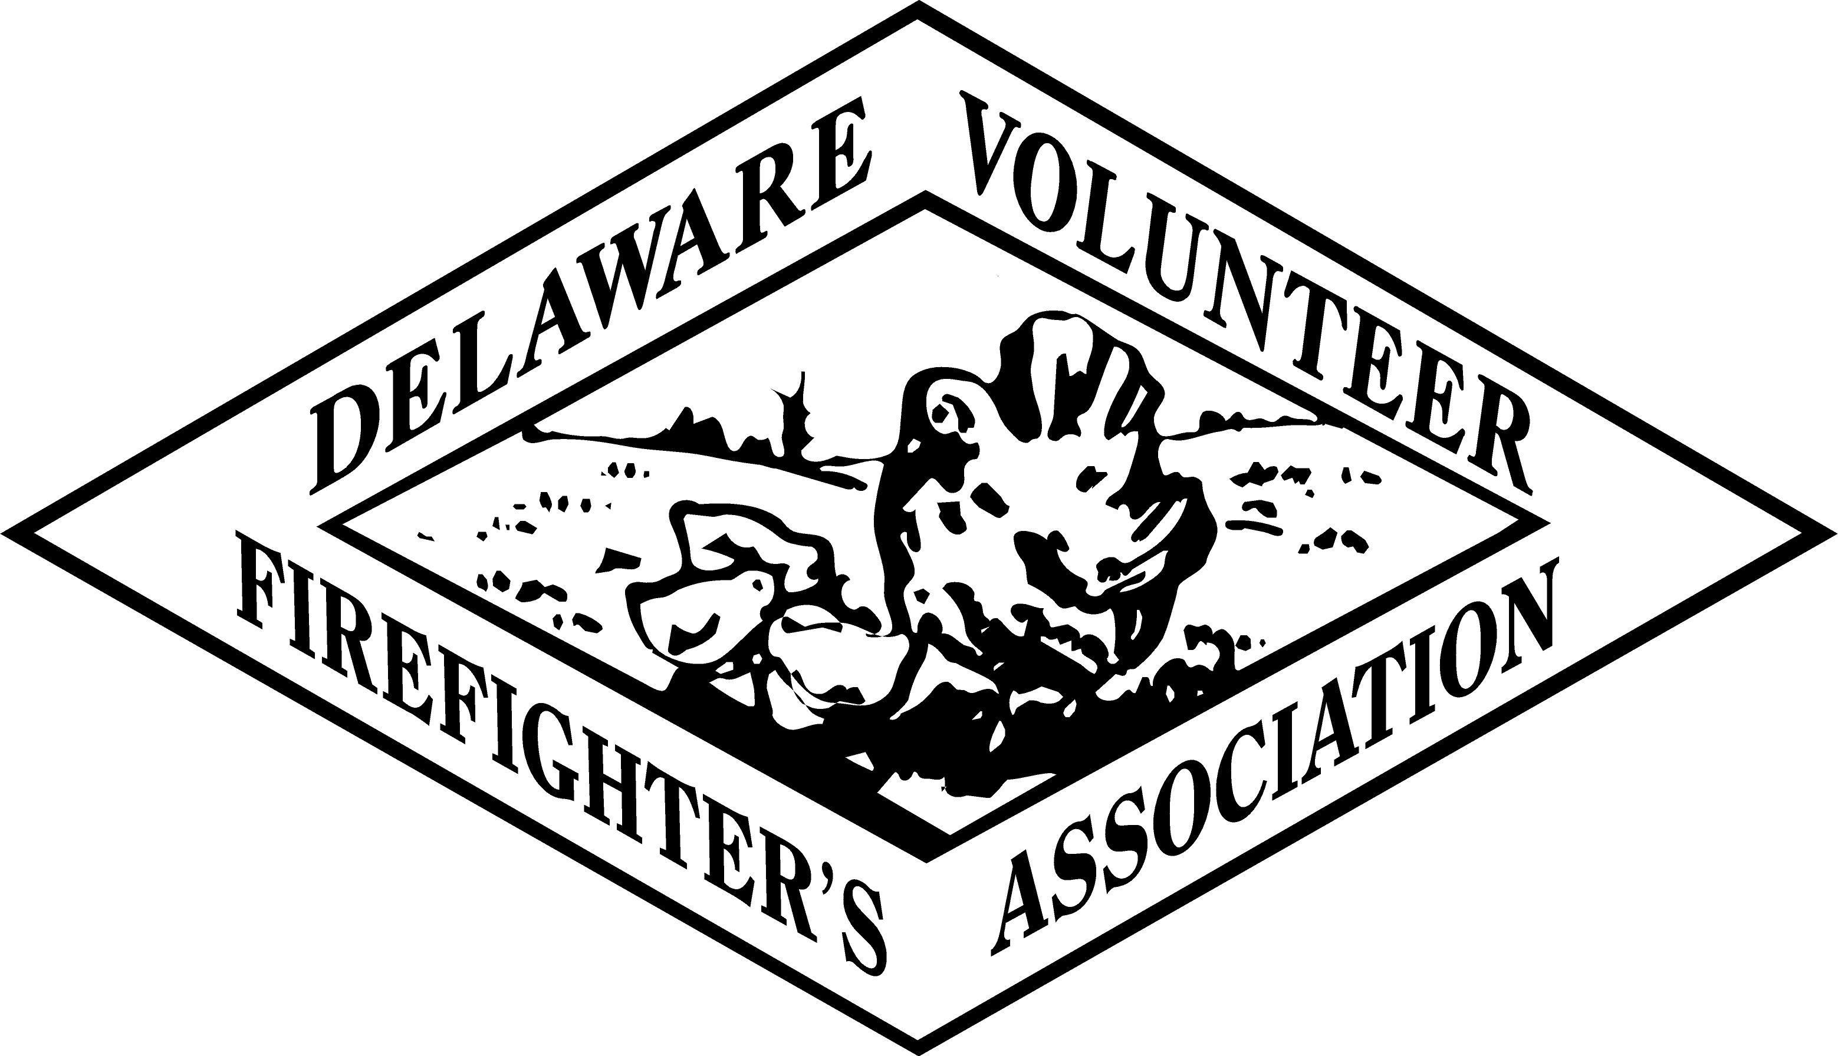 SCHOLARSHIP APPLICATION
DELAWARE VOLUNTEER FIREFIGHTER’S ASSOCIATION
VOLUNTEER FIREMEN’S INSURANCE SERVICE, INC.
(Fully Typed only)
(Note: You must be a member of a fire department, ladies auxiliary, or volunteer EMS company in good standing with the Delaware Volunteer Firefighter’s Association to be eligible for this scholarship.)

___________________________________________________________________________________
PERSONAL INFORMATION
Name: (First, Middle Initial, Last & Maiden if Applicable)
Home Address:
Home Telephone # Cell #: Email Address:
Date of Birth:
Student ID # if you have one: or Last 4 digits of Social Security Number:
___________________________________________________________________________________
HIGH SCHOOL INFORMATION
You must include a copy of your High School Transcript if not an applicant in 2018
High School Attended:
Mailing Address:
Date Graduated:
Grade Point Average:
If G.E.D., Give Date Earned and Location;
Scholastic and Athletic Honors Received in High School:

School and Community Activities Participated in High School (Include Offices Held):
___________________________________________________________________________________
COLLEGE INFORMATION
Attach copy of Official: Transcript
Enrollment in the following college program: (please HIGHLIGHT only one of the following)
Certificate Program Diploma Program Associates Bachelors Masters Doctoral
Name of Institution:
Mailing Address of Institution:
Matriculation Date: Projected Graduation Date:
Major *****(attach copy of Institution’s Curriculum)******
List any courses taken to date:
Scholastic and Athletic Honors received in College:

School and Community Activities in which you participated in College (Include Offices Held):

FIRE SERVICE INFORMATION
Name of Fire Department/Auxiliary/Volunteer EMS company:
Mailing Address:
Date Joined:
Offices Held:
Fire School Courses taken: (Attach Official Fire School Transcript and Copies of Other Completed Fire/EMS Certificated Courses)
___________________________________________________________________________________
LETTERS OF RECOMMENDATION
All applicants need to attach three (3) letters of Recommendation with the application. Letter(s) of Recommendations must accompany the application. (We will no longer accept Recommendation letters being mailed separately). 3 New letters of recommendation must be submitted annually !!!

Pg.2

___________________________________________________________________________________
AUXILIARY APPLICANTS INFORMATION
For Auxiliary members, the applicant needs to submit a letter or letters on Auxiliary Stationary from the Auxiliary President and/or Secretary verifying the applicant's participation in his/her number of Auxiliary activities/functions (exclusive of Company meetings) from March 1, 2018 through February 28, 2019. The hours participated in each event needs to be listed.

___________________________________________________________________________________
ESSAY
Enter here a TYPED Essay of approximately 250 words answering the following questions:
1) Why you are applying for financial assistance?
2) Why you believe this course of study will be useful to you and the area of Public Safety?
3) What are your career goals and objectives?
___________________________________________________________________________________
I hereby declare that all of the above information is complete and correct to the best of my knowledge. I also declare that I am a member of a fire department, ladies auxiliary, or volunteer EMS company in good standing with the Delaware Volunteer Firefighter’s Association to be eligible for this scholarship.

DATE: / / Signature: ______.

Return Application to:
DVFA Scholarship Committee
c/o Delaware Fire Service Center
Delaware State Fire School
1461 Chestnut Grove Rd.
Dover, DE 19904

Before turning in this application make sure all of the following requirements are completed. Any part not submitted will cause the whole application to be rejected:

1) Applicant MUST be a member of a fire department, auxiliary, or volunteer EMS company in good standing with the Delaware Volunteer Firefighter’s Association.
2) Application is FULLY TYPED and complete.
3) Attach a copy of High School Transcript if not an applicant the previous year.
4) Copy of College Curriculum.
5) Attach Official College Transcript.
6) All applicants must attach three (3) letters of Recommendation each year.
(Applicant must submit letters of recommendation with the application; do not have them mailed separately.)
7) For Auxiliary Member applicants, a letter(s) from your Company President and/or Secretary documenting your participation in Auxiliary activities/functions (exclusive of Company meetings) from March 1, 2018 through February 28, 2019. The hours participated in each event needs to be listed.
8) Typed Essay.
9) Attach fire school transcript and copies of other completed Fire/EMS certificated courses.
10) Application must be postmarked no later than March 30, 2019 to be judged.
11) This Application is not complete until the applicant’s verification of active status in their department is noted by the HANDWRITTEN signature of one of the officers noted below:
Fire Department President
Fire Chief
Ladies Auxiliary President

DATE: / / Signature: ______.

