Delaware Volunteer Firefighters Association

President First Vice President Second Vice President Secretary Treasurer Executive Manager
Willard “Bill” Betts Norman “Jay” Jones, Jr. Dan Carrier Elmer B. Steele Terry Whitham Warren F. Jones
P. O. Box 46 300 Railroad Ave. 847 N. Waterford La. 6259 Steffland Dr. P. O. Box 818 22626 Southern Pines Dr
Frederica, DE 19946 Ellendale, DE 19941 Wilmington, DE 19808 Seaford, DE 19973 Dover, DE 19901 Lewes, DE 19958
302-535-7080 C 302-381-9780 C 302-635-4224 C 302-542-8922 C 302-399-6472 C 302-535-4566 C

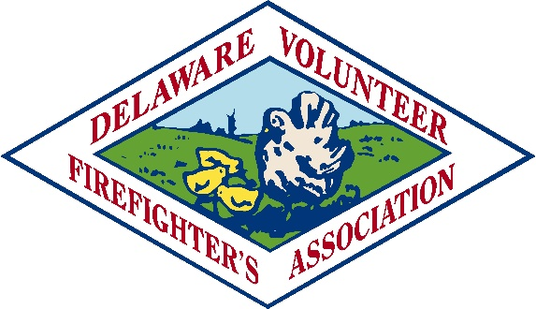
Past President County Presidents
Ted Walius Mark Gott
302-430-2765 New Castle County
302-420-1414 C
Directors
Tom DiCristofaro Michael Brittingham
New Castle County Kent County
302-293-3543 C 302-331-6226 C

Ken Ryder Hunter Holland
Kent County Sussex County
302-245-1417 C 302-258-5268 C

Ron O’Neal 122 South Bradford Street, P. O. Box 1849, Dover, DE 19903 DVFA Chaplain
Sussex County 302-734-9390 (Fax 302-734-9404) www.dvfassn.com Rev. Blake Bowers
302-249-3972 C “Serving Delaware’s Volunteer Fire Companies Since 1921” 302-519-3313 C

TO: 2019 DVFA SCHOLARSHIP APPLICANT
FROM: SCHOLARSHIP COMMITTEE
RE: APPLICATION PACKETS

Thank you for considering the Delaware Volunteer Firefighter’s Association Scholarship program. We have posted all of the necessary information to make your application to this program as simple as possible. Please remember that all information submitted to the Scholarship Committee must be typed and mailed directly to the address shown. DO NOT give any information to a DVFA firefighter or Ladies Auxiliary member for delivery to either the Fire School or to the Scholarship Committee. The Scholarship Committee will automatically reject information received in this manner.
Should you have specific questions, you may call ANY of the Co-Chairs of the DVFA Scholarship Committee: Ken Ryder at 302-245-1417, Ron O’Neal at 302-249-3972, or Anthony Guzzo at 302-239-7923. THE DEADLINE FOR THIS YEAR’S SCHOLARSHIP APPLICATION IS SATURDAY, MARCH 30, 2019. Remember, all information (i.e. application, letters of recommendation, college and fire school transcripts, etc.) must be postmarked no later than March 30, 2019, in order to be considered for this year’s scholarship.
GOOD LUCK!!
DVFA Scholarship Committee

