Firefighter of the Year Application | 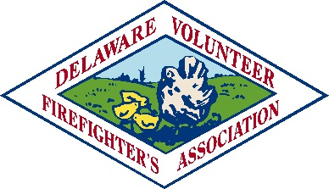

Personal Information
Name
Street Address
City ST ZIP Code
Home Phone
Cell Phone
E-Mail Address

Fire Company Information
Name
Street Address
City ST ZIP Code
Phone
Website

Applicant Information
Date joined fire company
Date of birth
Educational level
Current occupation
Name of employer
Address of employer
Phone number of employer
Offices held (if any)
Committees Serving on
Fire School Courses | Attach official Fire School Transcript and copies of other Fire or EMS Certified Courses
Letters of Recommendation | Attach three letters of recommendation. One from your fire chief and two others from fire service people of your choosing
Essay | Attach a 500 word or less essay describing why you joined the fire company, why you feel you should be selected for this award and what you would do to recruit and retain volunteer firefighters.

Applications and accompanying material must be received in the DVFA office by December 1, 2013. Mark on the outside of the envelope “Firefighter of the Year.”
Delaware Volunteer Firefighter’s Association
122 S. Bradford Street, Dover, DE 19903
302-734-9390

