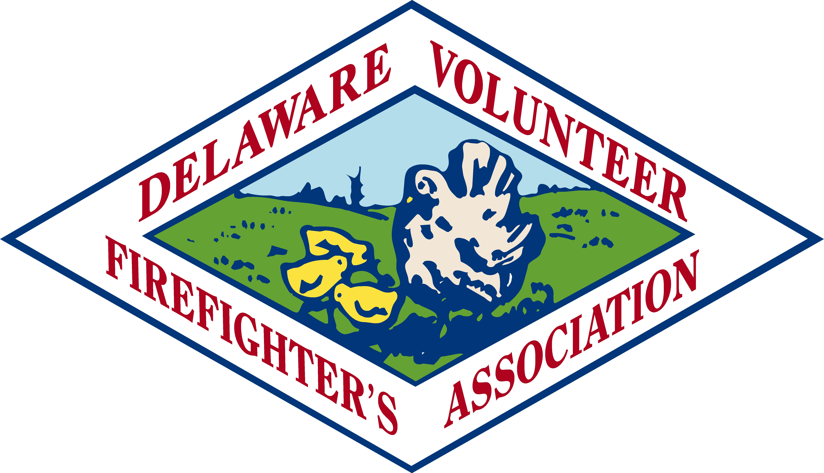

Delaware Volunteer Firefighter’s Association
Conference Committee
Exhibitor Rules and Regulations

- Exhibitor shall not use the Delaware Volunteer Firefighter’s Association [DVFA], Ladies Auxiliary Delaware Volunteer Firefighter’s Association or any affiliated associations nor any Conference Committee name, initials, acronyms, logos, its emblem, or any other property or parts thereof, without the expressed written permission of the Delaware Volunteer Firefighter’s Association or the DVFA Conference Committee.
- Exhibitor shall be responsible for all permits and licenses required to operate its booth/exhibit and to comply with all State and local laws, rules and regulations.
- Exhibitor agrees to be responsible for any claim for injury, loss or damage resulting from or arising out of his or her occupancy of the herein leased booths/exhibit space, or his participation in the Conference, and, in the event that any claim, hereby and herewith holds the Delaware Volunteer Firefighter’s Association, its DVFA Conference Committee, and its agents harmless from any liability arising out of such claims and agrees to execute any documents necessary to hold the DVFA harmless in accordance with the terms hereof.

- Exhibitor agrees to conform to all rules and regulations of the Delaware Volunteer Firefighter’s Association, its Conference Committee, and the Dover Downs Conference Center, concerning the operation of the exhibit space.

- Exhibitors will not be permitted to pack merchandise, dismantle booths, or move out early, without prior approval of the DVFA Conference Committee or its agents. Failure to comply could jeopardize future applications.

- Exhibitor agrees that he/she/it will not:
  - give away, sell or attempt to sell or display any sexually explicit, lewd or suggestive goods, merchandise, or wares
  - give away, sell or attempt to sell or display any alcoholic beverages of any type
  - give away, sell or attempt to sell or display any firearms or weapons
  - give away, sell or attempt to sell or display any item whose sale is prohibited by Federal, State and/or Local law
  - in any way disturb or interfere with the operation of their exhibits by adjacent exhibitors by loud or unseemly conduct or such conduct as, by design, would be intended to attract a crowd thereby interfering with the operation by adjacent exhibitors of their booth space.

- In the event the exhibitor shall fail or refuse to conform its conduct to the terms and conditions hereof or to a reasonable standard after request the Association’s authorized agent, the Association reserves to right to close the exhibit space without the necessity of resort of civil authority to enforce this provision, it being agreed and understood by the parties that the essence of the agreement is the orderly presentation of the Delaware Volunteer Firefighter’s Association Conference and its exhibits associated therewith.
- Exhibitor agrees that at the conclusion of the Lease, he/she/it will leave the exhibit space herein leased in the condition in which it was delivered at the inception hereof, and that during the term hereof Lessee shall maintain the area and premises leased in a safe condition, free of trash and debris and will clean the area of trash and debris at the expiration of the Lease. Failure to comply will result in the assessment of a clean-up charge in the amount incurred by the Association.
- All deposits and fees are non-refundable.
- The foregoing contains the entire agreement between the parties and is intended to be construed in accordance with Delaware law. Your signature on the exhibitor registration form means you have read and are in agreement with the rules and regulations of the Delaware Volunteer Firefighter’s Association Conference.

