Delaware Volunteer Firefighter’s Association and Ladies Auxiliaries
2018 Conference
September 12 – 14, 2018
Dover, Delaware

Annual Conference Booklet Advertising
The Delaware Volunteer Firefighter’s Association will hold their 24st Annual Conference on September 11 thru 14, 2018 at Dover Downs Hotel and Casino. This year, the conference committee will be selling ads to be included in the Annual Conference Booklet. These ads will be sold to businesses, fire companies, fire associations and individuals. They are available to advertise a business; to recognize fire service members for years of service; to honor a member for holding an office or a special anniversary and so much more. Listed below are the prices for the ads.

Ad size Price

Full Page $125.00

½ Page $ 75.00

¼ Page $ 50.00

1/8 Page $ 25.00

Patron Ad $ 2.00

All ads must be received by July 16, 2018. Please complete the form below and return, along with a copy of the ad and check to the address listed below. Also, please email the ad in .pdf format to DVFACONFERENCEBOOK@gmail.com. If you have any questions, please feel free to send an email to the address above. Please make the check payable to the Delaware Volunteer Firefighter’s Association and mail to:

Stacy Northam-Smith
914 West Street
Bethel, DE 19931
Attn: Conference Book.

Name of Fire Company/Individual/Business___________________________________
Address and Phone number_____________________________________________
Email address______________________________________________________
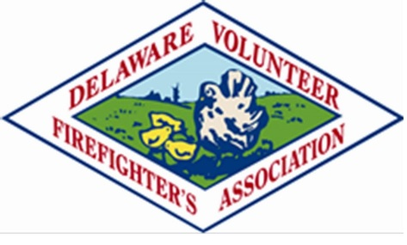
Ad Size ____________ Amount collected_____________________

