Report from the Cumberland Valley Firemen’s Association
Convention and Presidents Council Meeting

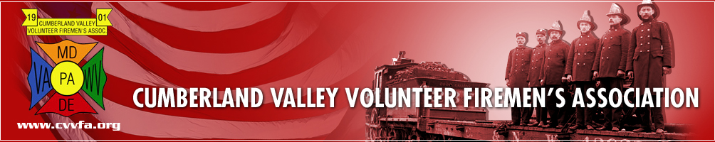

The CVVFA convention was held on Thursday and Friday, August 4 & 5, 2016 at the Level Fire Station in Havre De Grace, MD. Those attending from the DVFA were President Joe Zeroles, 1st Vice President Ted Walius, 2nd Vice President Rich Perillo, Secretary Elmer Steele, Treasurer J. Allen Metheny and Executive Manager Warren Jones.

We arrived at 1:00 PM on Thursday, registered and settled in for the afternoon business meeting, keynote speaker, budget approval and nomination of new officers per their new by-law change. It turned out to be a very exciting and unusual afternoon.

We left at 6:00 PM to attend the picnic being held at the Perryville VFC. There was lots of food, fun and fellowship for everyone in attendance.

We arrived at the fire station at 8:00 AM on Friday for the President’s Council meeting. This meeting involves reports, issues and concerns from the 7 States that are members of the Council, as well as reports from our National and Federal leaders. As you will see in this report, numerous issues and concerns are the same from State to State.

Our own Steve Austin was the MC for the meeting and kept things moving along on a steady pace.

CVVFA: CVVFA President Hoby Howell welcomed the members of the President’s Council to the
Level Fire Station for their convention meeting.

Cadet: Members of the Joppa-Magnolia Fire Co. reported on their CADET program and how it
has helped their company with recruitment. They presented a power-point video
showing how they keep their members active and interested within the fire and EMS
service.

Training: Dave Lewis invited anyone that was not a part of the President’s Council to come to a
training class next door. This will be an informal class and everyone is welcome.

New Jersey: Harry Carter brought greetings from New Jersey. He reported on a slowdown in the legislative process. He talked about their various legislative bills, budgets and some issues within the State.
New Jersey Convention is the same time as Delaware. September 14-17, 2016 in Wildwood, NJ

Delaware: Delaware Volunteer Firefighter’s Association President Joe Zeroles brought greetings from Delaware. Joe introduced the folks in attendance from Delaware and then turned the program over to Warren for a power point presentation. Warren discussed numerous issues that are of concern to Delaware; Grant in Aid, Joint Finance funding, R&R and our involvement with the Delaware State Fair. He discussed several legislative bills that were passed this year; HB406 (eliminate fees for background checks) and HB302 (double the cost of fines imposed for cell phone use). He also talked about the Special Olympics program “Over the Edge”
DVFA Conference will be held on September 12-17, 2016 at the Dover Downs Hotel & Casino in Dover, DE.

New York: Firemen’s Association of the State of New York (FASNY) Past President Dave Jacobowitz brought greetings from New York. He apologized for not having more representation in attendance from New York, but everyone is back home getting ready for their convention. He discussed legislative issues, cancer presumption, and SAFER grant.
FASNY 144th Convention will be held on August 10-13, 2016 in Albany, NY

Virginia: Virginia State Firefighter’s Association President Jeff Flippo brought greetings from the Commonwealth of Virginia. Jeff discussed the legislation to legalize ALL types of fireworks. They were pleased that this piece of legislation got DEFEATED. He stated that they are having some issues with LODD benefits.
VFSA 130th Convention will be August 17-20, 2016 at Hampton Roads Convention Center in Hampton, VA.

Maryland: MSFA President Michael Davis introduced his 1st and 2nd Vice President’s. He then gave reports and comments for the State of Maryland, MFRIS, MIEMSS, MEMA and Shock Trauma. MSP gave information on the aviation division and offered their help to any State that may need them.

West Virginia: The bill that was introduced to legalize fireworks in West Virginia did PASS to their dismay. Workman’s comp has dropped fire companies in West Virginia. They had to purchase private insurance to cover their members. There was supposed to be money put in at the legislative level to help with the cost of this private insurance, but at the last minute it was taken out. They have purchased a large amount of smoke detectors and can’t give them away.
West Virginia Convention will be August 11-13, 2016 at the Mardi Gras Casino & Resort in Cross Lanes, WV.

Pennsylvania: Ernie Rojahn brought greetings from Pennsylvania. They are working on grants for the coming year. They are also working on legislation dealing with cancer presumption and legalizing fireworks in the State. Don Konkle discussed other legislative issues.
Pennsylvania Convention will be September 21-24, 2016 at the Meadowlands Casino in
Washington, PA

At this time, the group broke for lunch (12:10 to 12:45)

National and Federal reports were given after lunch. There were several questions raised during the
presentations and not everyone was happy with some of the answers.

IAAI: Report was given for the International Association of Arson Investigators. Working on funding, wildland fires and sprinklers.

CFSI: Sean Carroll, Director of Government Affairs for the Congressional Fire Services Institute brought greetings from Washington. Sean discussed AFG and SAFER grants, FY 2017 funding, Firefighter Occupational Cancer, Fire Sprinkler Incentive Act, Recruitment & Retention and several other issues that CFSI is dealing with in Washington.

IAFC: Report was given for the International Association of Fire Chief’s.

NVFC: Report was given for the National Volunteer Fire Council. Working on funding, Recruitment and Retention and cancer presumption issues

CVVFA: CVVFA President Hoby Howell gave information on the remaining events for the Convention; banquet tonight, prayer breakfast tomorrow and parade tomorrow.

During the breaks, there was ample time to talk and socialize with the members from the different
States and Agencies in attendance. There was printed material and reports available with lots of
valuable information.

Respectfully submitted,
Elmer B. Steele
Elmer B. Steele, DVFA Secretary

