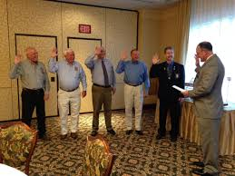

Thursday, June 16, 2016

President Zeroles, 1st Vice President Walius, 2nd Vice President Perillo and Secretary Steele represented the DVFA in Verona, NY to support Willard R. Betts (Frederica Fire Co.) on his installation as President of the Eastern Division of the International Fire Chief’s Association (EDIAFC). Also installed was Terry Jester (Memorial Fire Co.) as Delaware Director of the EDIAFC.

The Delaware Fire Service had 20 of it’s members, from various companies through out the State, attend this installation dinner to honor and support our folks from Delaware.

Congratulations to Bill and Terry on their installation as Officers of the EDIAFC

Report submitted by: Elmer Steele, DVFA Secretary

