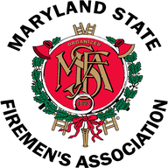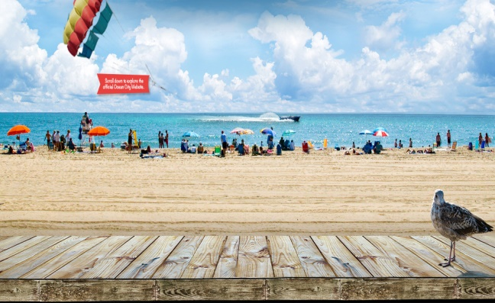
124th Annual Convention and Conference
Ocean City, MD.
June 18-24, 2016

President Zeroles, 1st Vice President Walius, Secretary Steele, Treasurer Metheny, Executive Manager Jones and Out-of-State Coordinator Steve Austin attended the opening of the Maryland State Firemen’s Association (MSFA) in Ocean City, MD on Monday, June 20, 2016. Also in attendance was EDIAFC President Betts and EDIAFC Director Jester.

MSFA President Johnie Roth, Jr. and LAMFSA President Darby Byrd called the Convention to order at 8:30 AM. The Convention proceeded with the normal order of business; recognition of Past President’s, recognition of guest and Out-of-State folks, welcome by the Mayor, Chief of the Fire Department, several local officials, as well as several legislative folks. Numerous awards, citations and certificates were presented through-out the course of the opening ceremonies.

Keynote speaker was: Sher Grogg – Common Voices
Vickie Pritchett – Executive Director – Common Voices
The presentation dealt with a tragic fire in the Annapolis Manson Fire that occurred on January 19, 2015, claiming the lives of six people. The fire originally started in the Christmas tree and spread through-out the entire Manson. Sher’s presentation was a voice for residential sprinklers. Sprinklers would have definitely made a difference in the out-come of this tragic fire.

After the keynote speaker, the normal order of business continued with the nomination of Officers for 2016-2017. Nominations were: President Michael Davis, 1st Vice President Mark Bilger,
2nd Vice President Richard Blair, Secretary Doyle Cox and Treasurer Ron Siarnicki.

As anyone knows, that has attended the opening ceremonies, after the nomination of each Officer, they “strike up the band” and parade each candidate around the room behind the band. This is a true sight to see, if you have never had the experience.

Congratulations to all of the newly elected Officers of the MSFA

Respectfully submitted:

Elmer B. Steele, DVFA Secretary

